Department of Education - Work at Home Software
Installation Guide for Microsoft Office 365 Apps on a Personally Owned Device

Please Note: The ICT Customer Service Centre is not able to provide advice or assistance relating to the installation or support of Work at Home software on personally owned devices. Further assistance can be found on the Microsoft website.

What you will need
  - To be an eligible Department employee or registered student
  - A valid Department e-mail address (@education.wa.edu.au or @student.education.wa.edu.au)
  - A valid staff or student login for Ikon or Connect
  - An internet connection with sufficient download allowance for over 1Gb per installation
(this cannot be downloaded on the Department network)

Installation on a Computer (not a tablet or mobile device) :

- Navigate to either Connect or Ikon
Click on the Envelope symbol  for Ikon or  for Connect at the top right-hand side of the page. This will take you to the browser or online version of Outlook, from where you can launch the installation.
- Click on the ‘Waffle’ (nine dots) on the upper left-hand side to bring up the list of online Apps (you may see fewer apps listed depending on your site or school preferences):
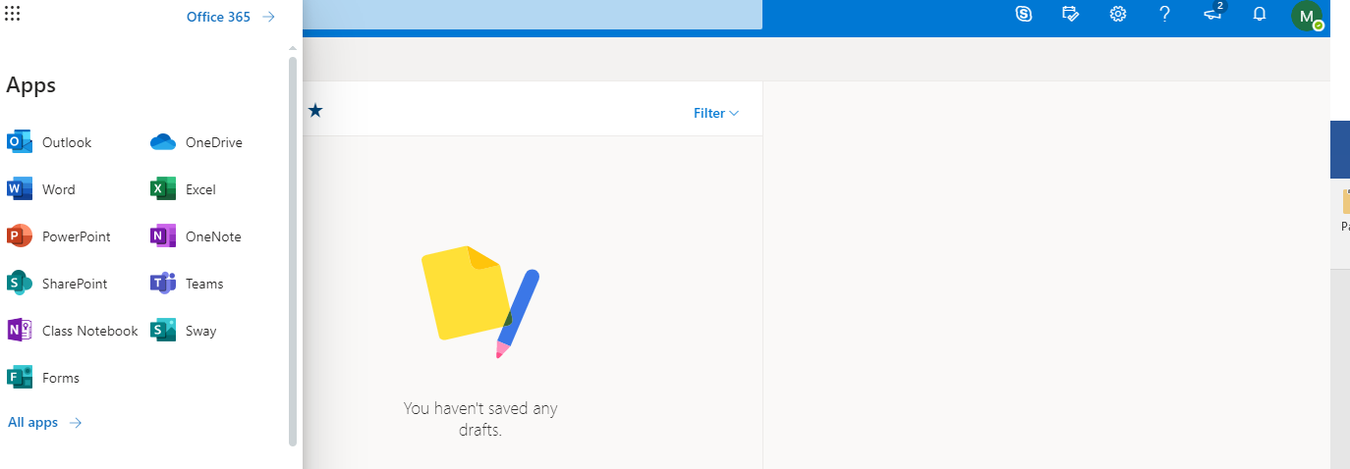

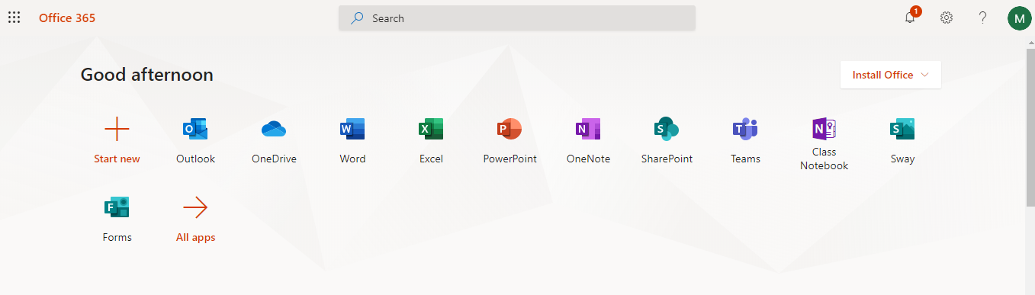
- Click on the link to the right of the nine dots to open an expanded Apps list where the Install Office link is available on the upper right:

- Click on ‘Install Office’ on the upper right of the screen, then follow the on-screen instructions to download and run Office setup:
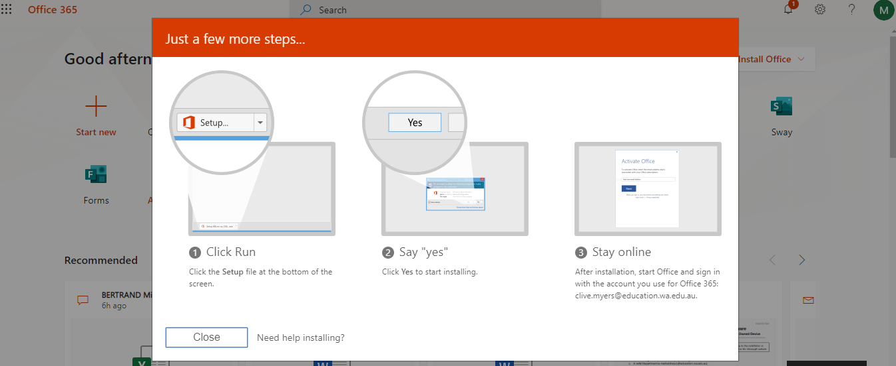

- If you see a prompt that says, Do you want to allow this app to make changes to your device? select Yes.
- Once the installation is complete, you can launch any Office app via the Start button as normal. The first time you launch an app you will be prompted to activate the license which will require signing in with your Department of Education email address, user name and password. Until the Office suite is activated or licensed you will not be able to save or edit files.
- Once activated, the apps are available to all users of that device.

Installation on a mobile device

Detailed guides to obtaining and installing the apps on phones and tablets can be found on the Microsoft Support – Set up Office apps and email on a mobile device web page where you can select the instructions for tablet or phone installation for both Android (including Chromebook) and iOS devices.

